St. Anthony High School

COM432E - Design Techniques for Website Report

St. Anthony High School Design Report

COM/15/17

Derrick Mbarani

Table of Contents

**sitemap1**

**wireframes2**

home page3

clubs and societies4

testimonials card5

gallery6

home page layout7

**typography8**

**colors9**

**layout10**

**texture10**

# Sitemap

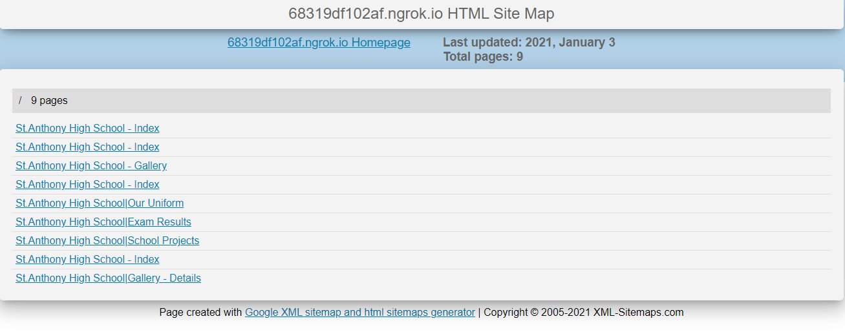

Human readable HTML sitemap as well as an XML sitemap is available on the project folder.

# Wireframes

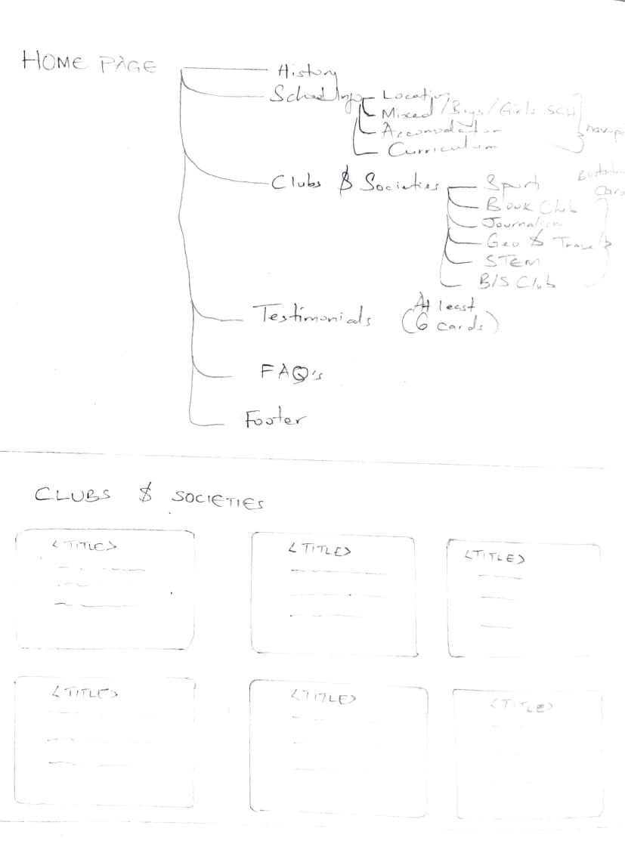

# 

# 

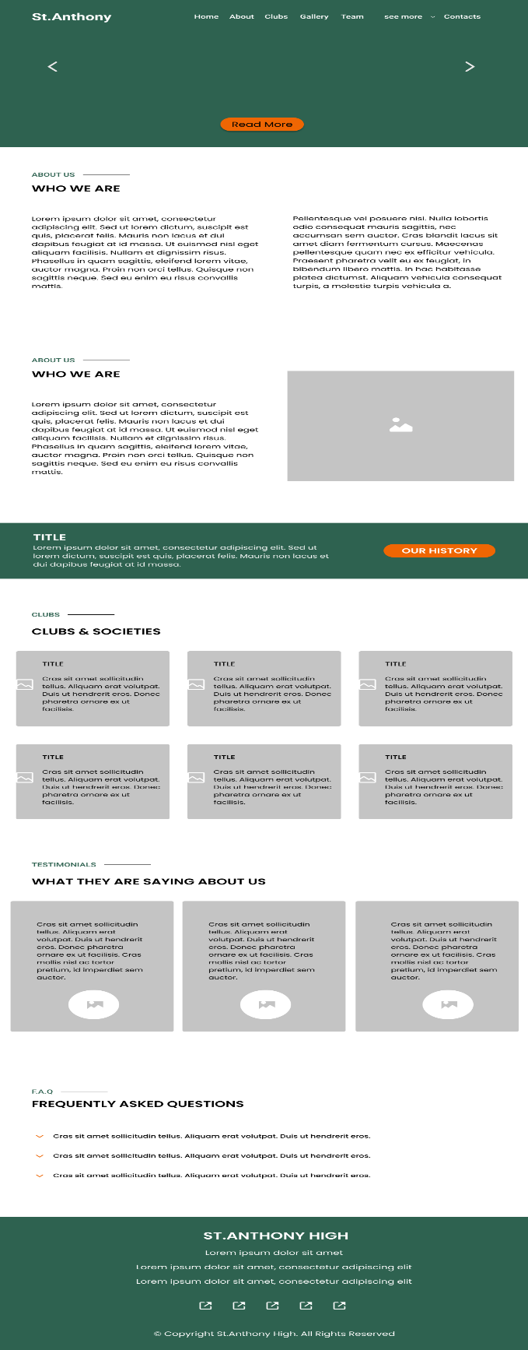A better view can be made from: https://www.figma.com/file/EzDa3XuMbpfPB2RsQ3FTCS/high-school-system?node-id=0%3A1

# Typography

Variants of sans-serif font has been applied to the website (Poppins, Raleway and Open Sans).

Poppins, one of the more popular sans-serif fonts on the web with a smoother edge giving an easier feel to the text. Makes text more readable and easier to the eyes. It is the dominant font since it has been used on the body tag, section titles in every page (h2 tags and p tags) and the footer.

Raleway is a sans serif font designed specifically for larger text (like headings). It has a simple, straightforward and elegant look making it suitable for larger headings. It is therefore well suited for headings and numerical figures on the site. It has been applied to h1, h3, h4, h5 and h6 tags on every page and the hero section on the fold of the home page.

Open Sans has also been applied to nav-menu class for the main site navigation.

The site has applied use of 3 fonts in line with website design guideline of a maximum of 2 to 3 fonts.

# Colors

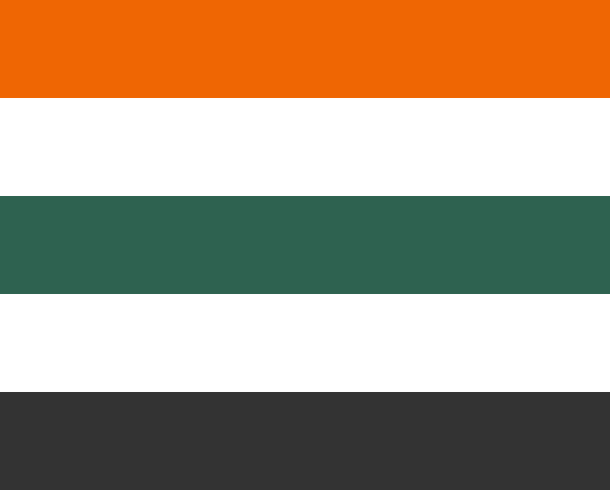

#2F6B54 -- Gable Green

#EF6603 -- Clementine

#333333 -- Mine Shaft

The aforementioned colors make up the Color palette of St. Anthony Website. The basis of choosing them is from the colors of the uniform with consists of a dominant Gable Green (school blazer; Used on the hero, section separator, nav-pills, top navigation active links and footer), Mine Shaft (school blazer, sweater, skirt and trousers; used on top navigation bar) and Clementine which is not represented in the school's uniform. Clementine was chosen since it’s a color that stick's out when combined with the other two colors hence suitable for elements for call to action as well as alongside lists to make them pop out. Clementine was used in place of #C7A395 -- Eunry, which is a dull color but on our uniform. White was also applied to bring out grouping and isolation of items on the web site to ensure they pop out and blend well with each other to achieve symmetry (horizontal symmetry).

# Layout

## Responsiveness

Responsive layout has been applied to ensure all screens are accommodated for easier interaction with the site.

Navigation Layout changes from Top Navigation to a column navigation on mobile that occupies the whole screen.

Other elements also adjust their size (fluid) and flow to occupy one column on smaller screens.

Fluidity and responsiveness have been achieved through use Bootstrap’s grid which has row and col classes that achieve it through various screen breakpoints.

## Rule of Thirds

The rule of thirds was also applied on the elements accompanied with pictures (*Gallery Details*, our *uniform page* and *project page*) to achieve aesthetic beauty.

The aforementioned pages consist of an image and text with tweaked dimensions to follow the rule of thirds.

## Horizontal Symmetry

Horizontal Symmetry has been applied in the *home page* - *about section*, *clubs* and *societies* section and *testimonials* section; on the *team page*.

# Texture

## Clean and Grainy Look

The overall background borrows a leaf from the clean and grainy look. The aim is to make the surface look more analog adding a touch of humanity and contrast to the digital surface. This has been accomplished through use of background image texture with: background: #fff url('./../img/white_wall_hash.png') repeat fixed; from subtlepatterns.com

## 3D Effect

Floating Nav Pills on the home page about section, submit button in contact us page and Floating Navigation on Exam Results Page creates an illusion of a 3-dimensional space through use of box-shadow CSS property. The goal is to make it stick out of the page.

## Volume and Depth

On click, inset box-shadow property is applied to (*index page* top navigation and *exam page* secondary navigation, submit button in *contact us* page) make it appear pressed.

The use of a darker shade of Clementine on the social links button (in the *footer* section) also makes them appear pressed on mouse hover

The application shadow by use of box-shadow promotes volume and depth therefore affecting texture.

## Movement and Excitement

Floating wavy hero at the fold of the *home page* evokes a sense of movement and excitement.

## Slippery Feel

The site also has rounded bordered navigation links and buttons (our history button in the *home page* *about section* and *contact us* button) which makes the site feel more slippery.